**Formula 1**

Research Document - Kaloyan Rakov

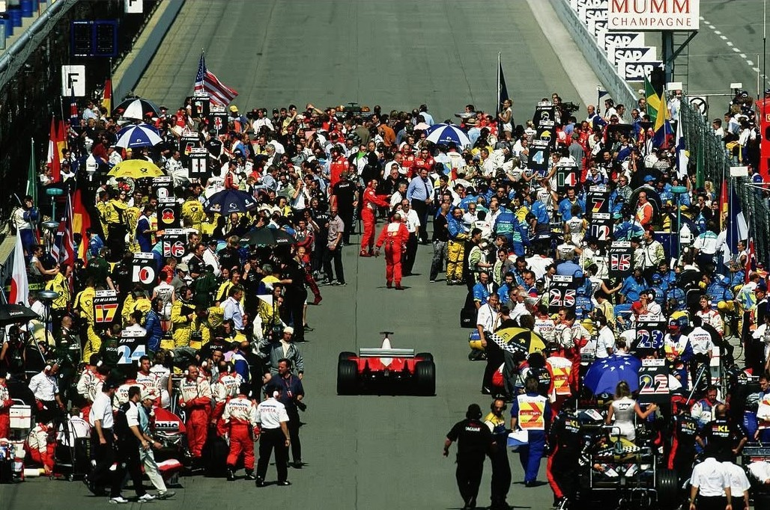



Table of contents:

1. Introduction
2. Basics of domain understanding
   1. Drivers & Teams
      1. Line-ups
      2. Works and Customer Teams
      3. Driver’s & Constructor Championships
   2. Qualifications

**Introduction**

Formula 1 is globally recognized as the pinnacle of motorsports and is a rapidly growing source of entertainment for millions of people. The sport is quite unique due to its use of heavy machinery, which in turn provides us with a lot of interesting data. This data could be used for predictions on how the races are going to end and this has proven to be a question that many would want to know the answer to. The aim of this project is to go in depth into what makes the sport what it is and along with the reader to try to get as close as possible to answering it.

This research document will function as an add-on to the notebook. Since the notebook goes more in-depth into the model building, a basic understanding of what Formula 1 is needed. This document can be used as an introduction to the topic and a deeper analysis then we have in the notebook.

**Basics of domain understanding**

In order to make the project understandable for people that have no previous knowledge about the topic, I will start by an in-depth explanation on what the Formula 1 season consist of and what exactly we are trying to do in the notebook.

**Drivers & Teams**

**Line-ups**

The 2025 Formula 1 season consist of 24 races across different countries. There are currently 10 teams participating, with each team consisting of 2 drivers. Here are the line-ups at the begging of the 2025 season:

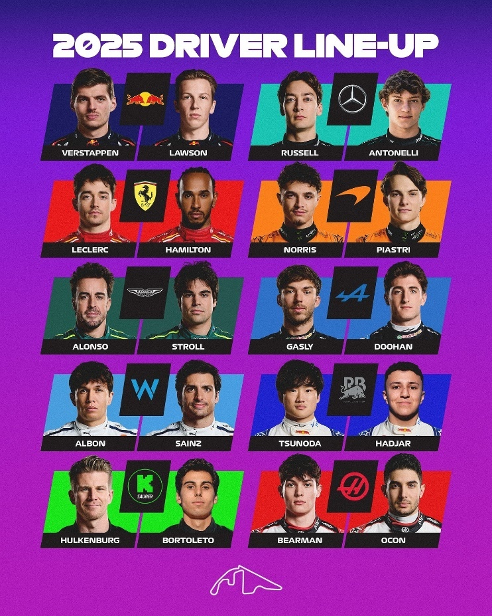

Red Bull Racing: Max Verstappen & Liam Lawson

Mercedes: George Rusell & Andrea Kimi Antonelli

Ferrari: Charles Leclerc & Lewis Hamilton

McLaren: Lando Noris & Oscar Piastri

Aston Martin: Fernando Alonso & Lance Stroll

Alpine: Pierre Gasly & Jack Doohan

Williams: Alex Albon & Carlos Sainz Jr.

Racing Bulls: Yuki Tsunoda & Isaak Hadjar

Kick Sauber: Nico Hulkenberg & Gabriel Bortoleto

Haas: Oliver Bearman & Esteban Ocon

The driver’s positions within their teams are not set in stone. The similarly in the names of “Red Bull Racing” and “Racing Bulls” is not a coincidence. They are both owned by the same company, the namesake of both those teams. This allows Red Bull the unique opportunity to have a de-facto second team – the Racing Bulls. This means that drivers can be switched between the two teams throughout the continuation of the season. Red Bull has actually taken advantage of this opportunity, so after round 2 of the Calendar Yuki Tsunoda and Liam Lawson were switched.

Another example of a team changing their line-up is Alpine firing Jack Doohan and replacing him with a new driver: Franco Colapinto.

**Works and Customer Teams**

There are two types of teams in F1:

Works Teams (aka Factory Teams) are the ones that are producing their own machinery, backed up by a motor manufacturer. Examples include Ferrari, Mercedes, etc.

Customer Teams are teams that are affiliated with a car company. Examples include Haas, Williams, Kick Sauber. These teams purchase their engines and other needed parts for their equipment from the works teams.

**Driver’s & Constructor Championships**

The main goal of the race, is of course for every driver to finish as high as possible in the final standings. Based on that each of them receives a certain number of points:

1st place: 25 points

2nd place: 18 points

3rd place: 15 points

4th place: 12 points

5th place: 10 points

6th place: 8 points

7th place: 6 points

8th place: 4 points

9th place: 2 points

10th place: 1 point

Positions from 11 to 20 are not awarded any points. The driver who sets the fastest lap of the race is awarded an extra point (provided he has finished in the top 10).

Whichever driver earn the greatest number of points at the end of the 24 races is awarded the Drivers Championship.

A team’s points are calculated by the sum of both of their driver’s points. Whichever team collect the greatest number of points is awarded the Constructors Championship.

**Qualification Rounds**

We are trying to predict the results at the end of a certain race; in order for us to do that it’s crucial for us to know the starting grid: The positions from which each driver *starts* the race. This order is decided in three qualifying rounds: Q1, Q2, Q3. Here is how it works:

Q1, Q2 and Q3 follow a “Knockout Format”.

Q1 is the beginning stage with all 20 drivers on the grid. This round is 18 Minutes and each driver tries to set a lap with a as fast of a time as possible. The bottom 5 drivers are eliminated and based on their fastest laps we get positions 16 – 20.

Q2 is the second stage, where the process repeats and again, the bottom 5 get eliminated. This stage lasts 15 Minutes and we get positions 15-11.

Q3 is the last stage where we get the last 10 drivers racing to decide the pole position (the racer who leads the pack, position number 1). Here we get the top 10 positions on the grid. This round last 12 minutes. After this round we get the full starting grid.

